MATH1031 Math for Health and sciences 2

Quiz #1 (Version A) – Summer 2021

(47 marks/ 5% of final grade)

PART A (12.5 marks in total)
The following data represents 50 people’s views on their favorite types of donuts:
Types of Donuts | Number of Responses | Percent | Corresponding Angle
Glazed | 15 | 30 | 108
Frosted | 12 | 24 | 86.4
Filled | 10 | 20 | 72
Plain | 5 | 10 | 36
Sprinkled | 8 | 16 | 57.6
Total | 50 | 100% | 360º

a. Fill in the values in the chart above. (5 marks; ½ mark each)

b. Draw a pie chart (use below circle) and label the percent and corresponding angle allocated to each type. (5.5 marks)

c. What is the percent of people who prefer filled donuts? (1 mark) 20 percent

d. What is the ratio of glazed donuts to frosted donuts? Please provide answer in lowest terms. (1 mark) 5:4
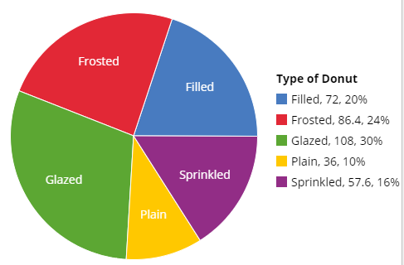
PART B (8 marks in total)
In a study of job satisfaction, a series of tests was administered to 30 nurses. The following data were obtained; higher scores represent greater satisfaction.
87, 76, 67, 58, 92, 59, 41, 50, 90, 75, 80, 81, 70, 33, 61, 88 46, 97, 50, 77, 82, 71, 46, 66, 78, 67, 81, 55, 65, 78
- Construct a stem-and-leaf plot for the data using the below graph. (5 marks)
- Using the stem and leaf plot, determine the lowest score in this study? (1 mark) 33
- How many nurses gave a score below 60? (1 mark) 9 nurses
- How many nurses gave a score of 80 or above? (1 mark) 9 nurses
Stem | Leaf
3 | 3
4 | 166
5 | 00589
6 | 15677
7 | 0156788
8 | 011278
9 | 027

Part C (26.5 marks in total)
The following data represent the weight (in pounds) of 20 third grade boys at an elementary school during a recent school health fair:

45.1, 52.8, 66.2, 70.0, 84.9, 82.1, 76.2, 53.9, 63.2, 48.6, 62.3, 78.2, 55.2, 68.5, 67.1, 73.0, 81.2, 47.3, 64.5, 65.4

a. Circle if this data is qualitative, quantitative discrete, or quantitative continuous? (1 mark)
b. Using the above data, fill in the below table with 5 classes, using 40 as the LCL of the first class. (12.5 marks; ½ mark each)
Weight (pounds) | Frequency | Relative Frequency | Cumulative Frequency | Relative Cumulative Frequency
40 - 50 | 3 | 15 | 3 | 15
50 - 60 | 3 | 15 | 6 | 30
60 - 70 | 7 | 35 | 13 | 65
70 - 80 | 4 | 20 | 17 | 85
80 - 90 | 3 | 15 | 20 | 100
TOTAL | 20 | 100
f. Create a histogram & a frequency polygon below for this set of data. (5 + 2 = 7 marks)
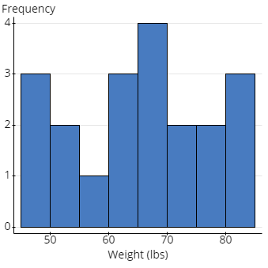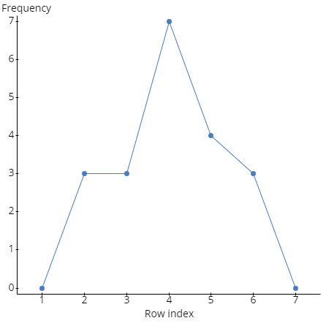
g. Create a Cumulative Frequency (Ogive) Curve below for this set of data. (3 marks)
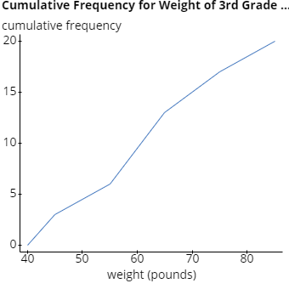
h. Based on the ogive curve, estimate:
(i) What % of the boys weigh 50 or fewer pounds? (1 mark) 15 %
(ii) What % of the boys weigh more than 50 but 70 or fewer pounds? (1 mark) 50 %
(iii) What % of the boys weigh more than 75 pounds? (1 mark) 10 %

